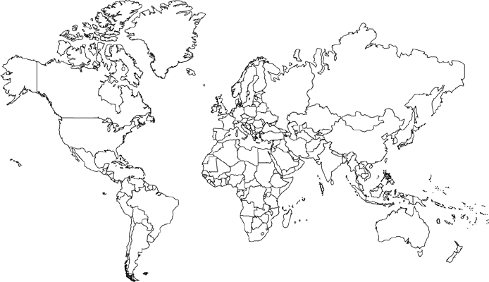
Imperialism Map: Create a key of the major imperial powers: British, French, Dutch, German, Spanish, American, and Japan

